Ajax Tutorial



AJAX tutorial covers concepts and examples of AJAX technology for beginners and professionals.

AJAX is an acronym for **Asynchronous JavaScript and XML**. It is a group of inter-related technologies like [JavaScript](https://www.javatpoint.com/javascript-tutorial), DOM, [XML](https://www.javatpoint.com/xml-tutorial), [HTML](https://www.javatpoint.com/html-tutorial)/[XHTML](https://www.javatpoint.com/xhtml-tutorial), [CSS](https://www.javatpoint.com/css-tutorial), [XMLHttpRequest](https://www.javatpoint.com/understanding-xmlhttprequest) etc.

AJAX allows you to send and receive data asynchronously without reloading the web page. So it is fast.

AJAX allows you to send only important information to the server not the entire page. So only valuable data from the client side is routed to the server side. It makes your application interactive and faster.

Where it is used?

There are too many web applications running on the web that are using ajax technology like **gmail**, **facebook**,**twitter**,**google map**, **youtube** etc.

# Understanding Synchronous vs Asynchronous

Before understanding AJAX, let’s understand classic web application model and ajax web application model first.

## **Synchronous (Classic Web-Application Model)**

A synchronous request blocks the client until operation completes i.e. browser is unresponsive. In such case, javascript engine of the browser is blocked.

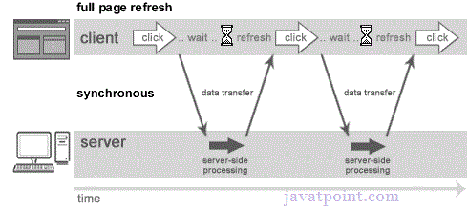

As you can see in the above image, full page is refreshed at request time and user is blocked until request completes.

Let's understand it another way.

Play Video[](https://campaign.adpushup.com/get-started/?utm_source=banner&utm_campaign=growth_hack)

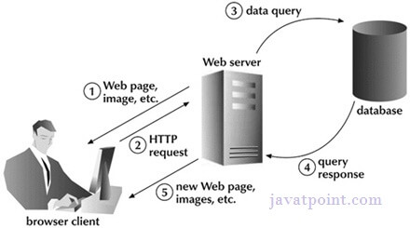

## **Asynchronous (AJAX Web-Application Model)**

An asynchronous request doesn’t block the client i.e. browser is responsive. At that time, user can perform another operations also. In such case, javascript engine of the browser is not blocked.

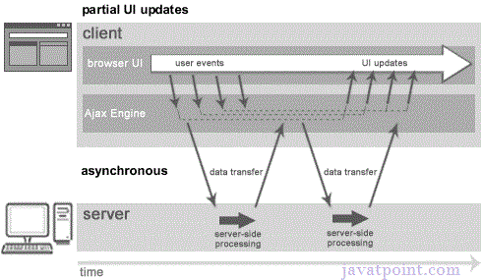

As you can see in the above image, full page is not refreshed at request time and user gets response from the ajax engine.

Let's try to understand asynchronous communication by the image given below.

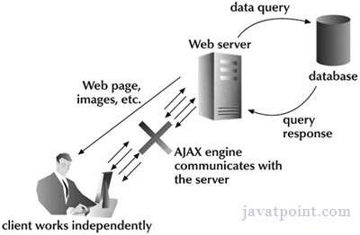

#### **Note: every blocking operation is not synchronous and every unblocking operation is not asynchronous.**

# AJAX Technologies

As describe earlier, ajax is not a technology but group of inter-related technologies. [AJAX](https://www.javatpoint.com/ajax-tutorial) technologies includes:

* [HTML](https://www.javatpoint.com/html-tutorial)/[XHTML](https://www.javatpoint.com/xhtml-tutorial) and [CSS](https://www.javatpoint.com/css-tutorial)
* DOM
* [XML](https://www.javatpoint.com/xml-tutorial) or [JSON](https://www.javatpoint.com/json-tutorial)
* [XMLHttpRequest](https://www.javatpoint.com/understanding-xmlhttprequest)
* [JavaScript](https://www.javatpoint.com/javascript-tutorial)

## **HTML/XHTML and CSS**

These technologies are used for displaying content and style. It is mainly used for presentation.

## **DOM**

It is used for dynamic display and interaction with data.

## **XML or JSON**

For carrying data to and from server. JSON (Javascript Object Notation) is like XML but short and faster than XML.

## **XMLHttpRequest**

For [asynchronous communication](https://www.javatpoint.com/understanding-synchronous-vs-asynchronous) between client and server. For more visit next page.

## **JavaScript**

It is used to bring above technologies together.

Independently, it is used mainly for client-side validation.

# Understanding XMLHttpRequest

1. [XMLHttpRequest](https://www.javatpoint.com/understanding-xmlhttprequest)
2. [Properties of XMLHttpRequest](https://www.javatpoint.com/understanding-xmlhttprequest)
3. [Methods of XMLHttpRequest](https://www.javatpoint.com/understanding-xmlhttprequest)

An object of XMLHttpRequest is used for asynchronous communication between client and server.

It performs following operations:

1. Sends data from the client in the background
2. Receives the data from the server
3. Updates the webpage without reloading it.

## **Properties of XMLHttpRequest object**

The common properties of XMLHttpRequest object are as follows:

|  |  |
| --- | --- |
| **Property** | **Description** |
| onReadyStateChange | It is called whenever readystate attribute changes. It must not be used with synchronous requests. |
| readyState | represents the state of the request. It ranges from 0 to 4.  **0** UNOPENED open() is not called.  **1** OPENED open is called but send() is not called.  **2** HEADERS_RECEIVED send() is called, and headers and status are available.  **3** LOADING Downloading data; responseText holds the data.  **4** DONE The operation is completed fully. |
| reponseText | returns response as text. |
| responseXML | returns response as XML |

## **Methods of XMLHttpRequest object**

The important methods of XMLHttpRequest object are as follows:

|  |  |
| --- | --- |
| **Method** | **Description** |
| void open(method, URL) | opens the request specifying get or post method and url. |
| void open(method, URL, async) | same as above but specifies asynchronous or not. |
| void open(method, URL, async, username, password) | same as above but specifies username and password. |
| void send() | sends get request. |
| void send(string) | send post request. |
| setRequestHeader(header,value) | it adds request headers. |

.

How AJAX works?

AJAX communicates with the server using XMLHttpRequest object. Let's try to understand the flow of ajax or how ajax works by the image displayed below.

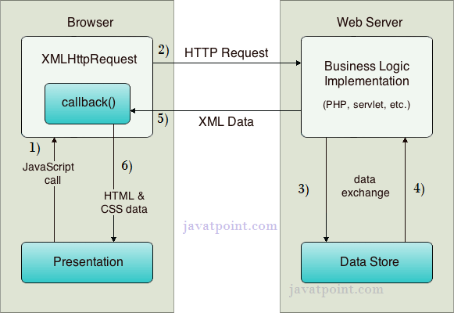

As you can see in the above example, XMLHttpRequest object plays a important role.

1. User sends a request from the UI and a javascript call goes to XMLHttpRequest object.
2. HTTP Request is sent to the server by XMLHttpRequest object.
3. Server interacts with the database using JSP, PHP, Servlet, ASP.net etc.
4. Data is retrieved.
5. Server sends XML data or JSON data to the XMLHttpRequest callback function.
6. HTML and CSS data is displayed on the browser.

AJAX JSON Example

We can get JSON data by AJAX code. AJAX provides facility to get response asynchronously. It doesn't reload the page and saves bandwidth.

AJAX JSON Example

Let's see a simple example of getting JSON data using AJAX code.

1. <html>
2. <head>
3. <meta content="text/html; charset=utf-8">
4. <title>AJAX JSON by Javatpoint</title>
5. <script type="application/javascript">
6. function load()
7. {
8. var url = "http://date.jsontest.com/";//use any url that have json data
9. var request;
11. **if**(window.XMLHttpRequest){
12. request=**new** XMLHttpRequest();//for Chrome, mozilla etc
13. }
14. **else** **if**(window.ActiveXObject){
15. request=**new** ActiveXObject("Microsoft.XMLHTTP");//for IE only
16. }
17. request.onreadystatechange  = function(){
18. **if** (request.readyState == 4  )
19. {
20. var jsonObj = JSON.parse(request.responseText);//JSON.parse() returns JSON object
21. document.getElementById("date").innerHTML =  jsonObj.date;
22. document.getElementById("time").innerHTML = jsonObj.time;
23. }
24. }
25. request.open("GET", url, **true**);
26. request.send();
27. }
28. </script>
29. </head>
30. <body>
32. Date: <span id="date"></span><br/>
33. Time: <span id="time"></span><br/>
35. <button type="button" onclick="load()">Load Information</button>
36. </body>
37. </html>

Output:

Date:

Time:

Load Information

# AJAX Interview Questions

A list of frequently asked AJAX interview questions and answers are given below.

### 1) What is AJAX?

AJAX stands for Asynchronous JavaScript and XML. It is a group of related technologies used to display data asynchronously. In other words, it sends and retrieves data without reloading the web page. [More details.](https://www.javatpoint.com/ajax-tutorial)

### 2) What are the advantages of AJAX?

* Quick Response
* Bandwidth utilization
* The user is not blocked until data is retrieved from the server.
* It allows us to send only important data to the server.
* It makes the application interactive and faster.

### 3) What are the disadvantages of AJAX?

* Dependent on JavaScript
* Security issues
* Debugging is difficult

### 4) What are the real web applications of AJAX currently running in the market?

* Twitter
* Facebook
* Gmail
* Javatpoint
* Youtube

### 5) What are the security issues with AJAX?

* AJAX source code is readable
* Attackers can insert the script into the system

### 6) What is the difference between synchronous and asynchronous requests?

Synchronous request blocks the user until a response is retrieved whereas asynchronous doesn't block the user. [More details.](https://www.javatpoint.com/understanding-synchronous-vs-asynchronous)

#### **Synchronous Request**



#### **Asynchronous Request**



### 7) What are the technologies used by AJAX?

* HTML/XHTML and CSS - These technologies are used for displaying content and style.
* DOM - It is used for dynamic display and interaction with data.
* XML - It is used for carrying data to and from server
* XMLHttpRequest - It is used for asynchronous communication between client and server.
* JavaScript - It is used mainly for client-side validation

[More details.](https://www.javatpoint.com/ajax-technologies)

### 8) What is the purpose of XMLHttpRequest?

* It sends data in the background to the server.
* It requests data from the server.
* It receives data from the server.
* It updates data without reloading the page.

[More details.](https://www.javatpoint.com/understanding-xmlhttprequest)

### 9) What are the properties of XMLHttpRequest?

The important properties of the XMLHttpRequest object are given below.

* onReadyStateChange - It is called whenever readystate attribute changes.
* readyState - It represents the state of the request.
* responseText - It returns response as text.
* responseXML - It returns response as XML.
* status - It returns the status number of a request.
* statusText - It returns the details of status.

[More details.](https://www.javatpoint.com/understanding-xmlhttprequest)

### 10) What are the important methods of XMLHttpRequest?

* abort() - It is used to cancel the current request.
* getAllResponseHeaders() - It returns the header details.
* getResponseHeader() - It returns the specific header details.
* open() - It is used to open the request.
* send() - It is used to send the request.
* setRequestHeader() - It adds request header.

[More details.](https://www.javatpoint.com/understanding-xmlhttprequest)

### 11) What are the types of open() method used for XMLHttpRequest?

* open(method, URL) - It opens the request specifying get or post method and URL.
* open(method, URL, async) - It is same as above but specifies asynchronous or not.
* open(method, URL, async, username, password) - It is same as above but specifies the username and password.

[More details.](https://www.javatpoint.com/understanding-xmlhttprequest)

### 12) What are the types of send() method used for XMLHttpRequest?

* send() - It sends get request
* send(string) - It sends post request.

[More details.](https://www.javatpoint.com/understanding-xmlhttprequest)

### 13) What is the role of the callback function in AJAX?

The callback function passes a function as a parameter to another function. If we have to perform various AJAX tasks on a website, then we can create one function for executing XMLHttpRequest and a callback function to execute each AJAX task.



### 14) What is JSON in AJAX?

JSON stands for JavaScript Object Notation. In AJAX, it is used to exchange data between a browser and a server. It is easy to understand, and data exchange is faster than XML. It supports array, object, string, number, and values.

1. request.onreadystatechange  = function(){
2. if (request.readyState == 4  )
3. {
4. var jsonObj = JSON.parse(request.responseText);//JSON.parse() returns JSON object
5. document.getElementById("date").innerHTML =  jsonObj.date;
6. document.getElementById("time").innerHTML = jsonObj.time;
7. }
8. }

### 15) What are the tools for debugging AJAX applications?

There are several tools for debugging AJAX applications.

* Firebug for Mozilla Firefox
* Fiddler for IE (Internet Explorer)
* JavaScript HTML Debugger
* MyEclipse AJAX Tools
* Script Debugger

### 16) What are the types of post back in AJAX?

There are two types of post back in AJAX.

* Synchronous Postback - It blocks the client until the operation completes.



* Asynchronous Postback - It doesn?t block the client.



### 17) What are the different ready states of a request in AJAX?

There are 5 ready states of a request in AJAX.

* 0 means UNOPENED
* 1 means OPENED
* 2 means HEADERS_RECEIVED
* 3 means LOADING
* 4 means DONE

[More details.](https://www.javatpoint.com/understanding-xmlhttprequest)

### 18) What are the common AJAX frameworks?

* Dojo Toolkit
* YUI
* Google Web Toolkit (GWT)
* Spry
* MooTools
* Prototype

### 19) How can you test the AJAX code?

JUnit is the open source unit testing framework for client-side JavaScript. It is required to create test cases. The unit test case is a code which ensures that the program logic works as expected.

### 20) What is the difference between JavaScript and AJAX?

|  |  |
| --- | --- |
| JavaScript is an object-based scripting language. | AJAX is a group of inter-related technologies like JavaScript, XML, HTML, CSS etc |
| It requests the server and waits for the response. | It sends a request to the server and doesn't wait for the response. |
| It consumes more bandwidth as it reloads the page. | It doesn't reload the page so consumes less bandwidth. |